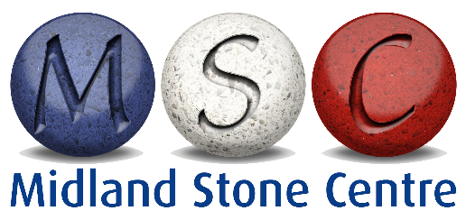

Care to Quartz-Based finishes in kitchens and bathrooms

Quartz is available in different face finishes, namely polished, honed and textured.

All good quartz-based stone contains generally 93% crushed quartz,
silica, sometimes crushed mirror and glass according to the colour selected
and is bonded together with about 7% polyester resin and colouring. It is much-
more durable than granite, being 15% harder and 5 times stronger and is
almost totally stain resistant with a porosity factor of .02% compared with
granite of .5%. (all figures approx)

Users can enjoy the product, needing only to exercise minimal care and common sense with substances normally expected to stain such as oil, acid, tea or coffee.

Note that caustic oven cleaning and de-scaling agents will damage the polish and discolour the product. NEVER USE these on or near the face of the stone. If in doubt ASK before using.

Polished Quartz is easy to clean and look after. Wipe clean on a regular basis but avoid dragging things across the face where possible. Better to “lift and place” any objects as required. Generally, quartz is harder than metal, so cutting on the tops may leave a metal residue. This can be cleaned off using Astonish or Cif cream cleaner. We recommend you use a chopping board. Do not apply polish as it will lie on the surface and eventually become marked and patchy.

Quartz is moderately heatproof during brief contact but always use heat mats for prolonged contact. High temperatures can cause thermal shock, discolouration and cracking. Assessing temperatures of pans from the hob is very difficult.

Honed faces (similar in appearance to eggshell paint) should be treated in a similar way. As they are not polished, they may require slightly more effort to clean than polished quartz. Use non- abrasive cream cleaners or Bleach to remove stubborn dried-on spillages.

Care of textured faces needs to be as you feel is required. It will depend on the type and depth of texture but all texturing should require only slightly more effort to clean than other finishes. On occasions, the use of a small soft brush may assist with dried-on or built-up grime.
z
Although the foregoing information has been gained from years of experience, it does not guarantee against damage caused by neglect or misuse of your worktops. It is specific to Quartz and not necessarily applicable to marble or granite.

